MOD Plug-in
SeaChange
Detailed Design Document
Version 0.6
.

Revision History
Date | Version | Description | Author
2004-11-2 | 0.1 | Document Created | Huang Yingting
2004-11-8 | 0.2 | Document Revised | Huang Yingting
2004-12-9 | 0.3 | Document refined according to SOAP interface | Ken Qian
2005-2-22 | 0.4 | Change MoDSoapResultModel’s data type. Change price type from decimal to be double, change the result type from Boolean to be integer.  Adding processing for Preview request(Billing ID = 0) | Ken Qian
2005-3-15 | 0.5 | Adding field”ProviderID” and “ProviderAssetID” to MoDSoapResultModel for OTE Credit checking and Review checking.  Adding credit checking failure codes and description.  Remove preview checking by setting BillingID=0 in Ver0.4 | Ken Qian
2005-7-13 | 0.6 | Using gSOAP instead of MSSOAPToolkit3.0 for MSSOAP’s mem leaking.  Update RentalTime & RentalPrice to MOD after OTE doing the credit checking. | Ken Qian
2005-7-18 | 0.7 | Support multiple application sites(OTE) to do credit checking. | Ken Qian

Table of Contents
1. Introduction 4
1.1 Purpose 4
1.2 Definitions, Acronyms, and Abbreviations 4
1.3 References 4
1.4 Overview 4
2. System Sequence View 5
3. MOD Plug-in Interface 6
3.1 Interfaces with MOD 6
3.2 TLV Parse 9
3.3 Data Structures 9
4. Design description 12
4.1 Architecture 12
4.2 SOAP Interface 13
4.3 Class View 14
4.3.1 MODAuthorization Class View 15
4.4 Workflow 15
4.5 Register Setting 16
5. Error Handling 17

MOD Plug-in

Introduction

Purpose
This document provides a detailed design of the MOD plug-in project, intended to give a comprehensive understand on this project.

Definitions, Acronyms, and Abbreviations
MOD: Movie on Demand.
SOAP: Simple Object Access Protocol
WSDL: Web Services Description Language

References
[R01] MAC_PlugIn_specification-02.doc

Overview
SeaChange has introduced the Movies on Demand Service Plug-In Dll architecture for interfacing with external systems. The goal of this architecture in to provide a standard and extensible way for the Movies On Demand Services (MOD) to support multiple interfaces to external systems.
MOD Plug-in project uses this architecture integrated with OTE to provide a general way to deal with stream set up and tear down.
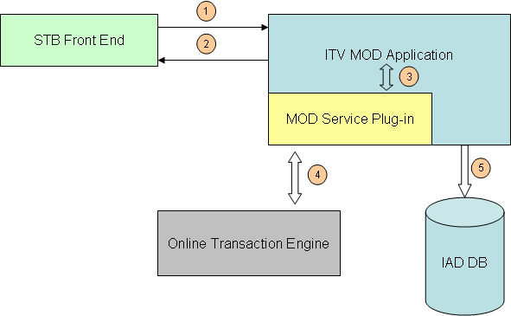
- STB Front End pass stream set-up and stream tear down request to ITV MOD Application.
- ITV MOD Application returns request result to STB Front End.
- ITV MOD Application internal calls MOD Service Plug-in to handle these requests.
- MOD Service Plug-in calls Online Transaction Engine and passes information to Online Transaction Engine through SOAP protocol. Online Transaction Engine passes back result to MOD Service Plug-in.
- MOD Application stores information into IAD DB.

System Sequence View
This section describes the sequence view of MOD Plug-in.
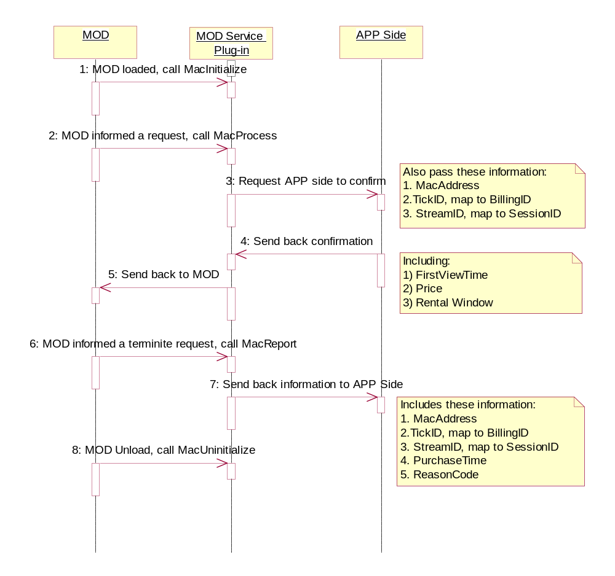
- MacPrcoess doesn’t provide PurchaseTime, so the only way is through MacReport.
- If timeout occurred in the communication between MOD Plug-in and APP side, MOD Plug-in will return failed to MOD immediately.

MOD Plug-in Interface
This section explains the MOD Plug-inn’s interface with MOD and APP side.

Interfaces with MOD
Being a dll called by MOD, MOD Plug-in must implement these interfaces below:
1. ITVSTATUS MacInitialize (MACHANDLES *pHandles, MACCALLBACKS *pCallbacks)
Description
This function performs any initialization the plug-in wishes to make.
Parameters
MACHANDLES IN Address of structure used to pass
1.) a management package handle to the DLL.
2.) the instance ID of the invoking MOD
3.) a count of IDS data available to MacProcess
4.) an array of IDS data available to MacProcess
5.) a count of IAD data available to MacReport
6.) an array of IAD data available to MacReport
MACCALLBACKS IN Address of structure used to pass
1.) an unload callback so that the DLL can signal MOD to unload itself.
2.) an allocate callback so that the DLL can create a TLV. MOD will free the TLV.
3.) an update callback so that the DLL can update a subset of IDS data in a stream's session object.
Returns
This function returns a status code from the ITV platform error set.
The DLL should set the bRequested flag in the IDS and IAD arrays for desired data.
All IDS array entries flagged as 'requested' will be supplied on each MacProcess invocation. All IAD array entries flagged as 'requested' will be supplied on each MacReport invocation.
If the DLL invokes the unload callback, MOD will behave as though the DLL had never been loaded; it will automatically authorize all subsequent requests. A warning is written to the NT Event Log when this happens and an alarm will be generated to let the operator know that authorization checking has stopped.
2. ITVSTATUS MacProcess (BYTE *pRequest, BOOL *pbResponse)
Description
This function determines whether or not a client is authorized to stream a movie.
It is given data about the request on which it is expected to perform the check.
It must accept or reject the request by setting the response value to TRUE or FALSE.
Parameters
pRequest IN TLV ("Type-Length-Value") byte stream containing: MacAddress, BillingId, SmartCardId, HomeId, StreamId and IDS data requested by MacInitialize.
pbResponse IN OUT The address of variable in which the result is placed.
Returns
This function returns a status code from the ITV platform error set. If the return value is ITV_SUCCESS and *pbResponse is TRUE, MOD will accept the request. If the return value is not ITV_SUCCESS or if *pbResponse is FALSE, MOD will reject the request.
The MOD service will track the minimum, mean and maximum amount of time it takes to process authorization checks and report them via ManUtil.
While in this function, the DLL can override certain IDS data for the current session by constructing a TLV of the data to be updated and passing it back to MOD. The TLV should be allocated using the pfnAllocRtn callback. Invoking the pfnUpdateRtn callback instructs MOD to update the session and release the TLV memory.
NOTE: MacProcess is a synchronous call. If MacProcess fails to return within a configurable amount of time, MOD can be configured to temporarily grant authorization. When MacProcess returns, MOD will terminate the stream if the response indicates an authorization failure. The release code of a terminated stream due to an authorization failure after a timeout is the same as that of a rejected stream due to an authorization failure.
WARNING: This function must be thread-safe; MOD can use a configurable number of threads to invoke it, i.e. 10 concurrent requests are received, 10 concurrent MacProcess invocations can be made.
3. ITVSTATUS MacReport (BYTE *pRequest, BOOL *pbResponse)
Description
This function supplies IAD billing data for a terminated stream.
It is given data about the request on which it is expected to perform the check.
It should acknowledge the request by setting the response value to TRUE or FALSE.
Parameters
pRequest IN TLV ("Type-Length-Value") byte stream containing: StreamId and IAD data requested by MacInitialize.
pbResponse IN OUT The address of variable in which the result is placed.
Returns
This function returns a status code from the ITV platform error set.
The MOD service will track the minimum, mean and maximum amount of time it takes to process 'reports' and display them via ManUtil.
NOTE: MacReport is a synchronous call. MOD service uses the same thread to update IAD as it does to invoke MacReport. Delays in processing a MacReport request will impact MOD's updating of IAD.
4. ITVSTATUS MacUninitialize ()
Description
This function performs any cleanup the plug-in wishes to take.
NOTE: After a request to unload the DLL has been made (either by the DLL or MOD), MOD will not make any more MacProcess calls and it will wait for all outstanding MacProcess calls to complete before invoking MacUninitialize.
Parameters
None.
Returns
This function returns a status code from the ITV platform error set.

TLV Parse
The pRequest parameter in MacProcess and MacReport is TLV type. So the algorithm parse TLV type is below:
- Read Type flag(T)
- Read Value Length(L)
- Read Value(V)
The type flag of MOD Services Plug-in is defined in R01.

Data Structures
// From SeaInclude.h; A version structure for specifying the version of a product, exe, dll, lib, etc
typedef union _ITVVERSION {
WORD wVersion; // The whole version, can compare.
struct
{
BYTE byteMinor; // Minor version, 0-99
BYTE byteMajor; // Major version, 0-255
} VersionComponents;
} ITVVERSION, *P ITVVERSION;

// From mac_interfaces.h; These header file defines the interface between MOD and the DLLs that it loads

// Version Number for Structures
#define MAC_MAJOR_VERSION 2
#define MAC_MINOR_VERSION 0
#define MAC_VERSION_2_0 0x0200

typedef struct _MACINFO {
BOOL bRequested; // Does the DLL want this data when MAC_PROCESS_RTN or
// MAC_REPORT_RTN is invoked?
WCHAR wszName[255]; // Name
WORD wTag; // See request tags below
} MACINFO;

typedef struct _MACHANDLES {
ITVVERSION Version; // Version of structure
HANDLE hMgmt; // Management handle for DLL to provide mgmt interface
WORD wID; // Instance Id of MOD
WORD wDsInfo; // The number of DS values in ppDsInfo
MACINFO **ppDsInfo; // DS data requested when invoking MAC_PROCESS_RTN
WORD wAdInfo; // The number of AD values in ppDsInfo
MACINFO **ppAdInfo; // AD data requested when invoking MAC_REPORT_RTN
} MACHANDLES;

typedef BOOL (__cdecl *MAC_UNLOAD_RTN) (void);
typedef BYTE * (__cdecl *MAC_ALLOC_RTN) (DWORD dwLength);
typedef ITVSTATUS (__cdecl *MAC_UPDATE_RTN) (STREAMID Sid,
BYTE *pRequest,
BOOL *pbResponse);
typedef struct _MACCALLBACKS {
ITVVERSION Version; // Version of structure
MAC_UNLOAD_RTN pfnUnloadRtn; // Causes DLL to be unloaded
MAC_ALLOC_RTN pfnAllocRtn; // Used by DLL to allocate TLV used by MAC_UPDATE_RTN
MAC_UPDATE_RTN pfnUpdateRtn; // Used by DLL to update Session data
} MACCALLBACKS;
#define MAC_TAG_MACADDRESS 1
#define MAC_TAG_BILLINGID 2
#define MAC_TAG_HOMEID 3
#define MAC_TAG_SMARTCARDID 4
#define MAC_TAG_STREAMID 5

typedef ITVSTATUS (__cdecl *MAC_INIT_RTN) ( MACHANDLES *pHandles,
MACCALLBACKS *pCallbacks);
typedef ITVSTATUS (__cdecl *MAC_UNINIT_RTN) (void);
typedef ITVSTATUS (__cdecl *MAC_PROCESS_RTN) (BYTE *pRequest,
BOOL *pbResponse);

#define MAC_TAG_DS_ASSET_LENGTH 21
#define MAC_TAG_DS_ASSET_PRICE 22
#define MAC_TAG_DS_ASSET_ANALOG_COPY_CHARGE 23
#define MAC_TAG_DS_ASSET_ANALOG_COPY_ALLOWED 24
#define MAC_TAG_DS_ASSET_VCR_ALLOWED 25
#define MAC_TAG_DS_ASSET_VCR_CHARGE 26
#define MAC_TAG_DS_ASSET_COMPUTED_PRICE 27
#define MAC_TAG_DS_ASSET_RENTAL_TIME 28
#define MAC_TAG_DS_ASSET_PREVIEW_TIME 29
#define MAC_TAG_DS_ASSET_CONTENT_PROVIDER 30
#define MAC_TAG_DS_ASSET_GENRE 31
#define MAC_TAG_DS_ASSET_SHORT_TITLE 32
#define MAC_TAG_DS_ASSET_RENTAL_TYPE 33
#define MAC_TAG_DS_ASSET_VIEWING_TIME 34
#define MAC_TAG_DS_ASSET_VIEWING_TYPE 35
#define MAC_TAG_DS_ASSET_SCRAMBLED 36
#define MAC_TAG_DS_ASSET_SCRAMBLED_TIME 37
#define MAC_TAG_DS_ASSET_SCRAMBLED_TYPE 38
#define MAC_TAG_DS_ASSET_EVENT_ID 39
#define MAC_TAG_DS_ASSET_DEACTIVATE_TIME 40
#define MAC_TAG_DS_ASSET_SUSPENDABLE 41
#define MAC_TAG_DS_ASSET_PROVIDER 42
#define MAC_TAG_DS_ASSET_RATING 43
#define MAC_TAG_DS_ASSET_ASSET_TITLE 44
#define MAC_TAG_DS_ASSET_ASSET_BRIEF_TITLE 45
#define MAC_TAG_DS_ASSET_PROVIDER_ID 46
#define MAC_TAG_DS_ASSET_PROVIDER_ASSET_ 47

#define MAC_TAG_DS_FOLDER_PRICINGOPTIONS 48
#define MAC_TAG_DS_FOLDER_PRICINGVALUE 49
#define MAC_TAG_DS_FOLDER_SUSPENDLISTOPTIONS 50
#define MAC_TAG_DS_FOLDER_SUSPENDLISTLIFETIME 51
#define MAC_TAG_DS_FOLDER_PACKAGEID 52
#define MAC_TAG_DS_FOLDER_BILLINGTAG 53

#define MAC_TAG_AD_TYPE 101
#define MAC_TAG_AD_MAC_ADDRESS 102
#define MAC_TAG_AD_BILLING_ID 103
#define MAC_TAG_AD_ASSET_ID 104
#define MAC_TAG_AD_TITLE 105
#define MAC_TAG_AD_SHORT_TITLE 106
#define MAC_TAG_AD_BILLABLE 107
#define MAC_TAG_AD_ASSET_PROVIDER 108
#define MAC_TAG_AD_ANALOG_COPY_ALLOWED 109
#define MAC_TAG_AD_ASSET_GENRE 110
#define MAC_TAG_AD_FAST_FORWARD_COUNT 111
#define MAC_TAG_AD_REWIND_COUNT 112
#define MAC_TAG_AD_PAUSE_COUNT 113
#define MAC_TAG_AD_PLAY_TIME 114
#define MAC_TAG_AD_PRICE 115
#define MAC_TAG_AD_PURCHASE_TIME 116
#define MAC_TAG_AD_RENTAL_TIME 117
#define MAC_TAG_AD_HOME_ID 118
#define MAC_TAG_AD_SMART_CARD_ID 119
#define MAC_TAG_AD_PURCHASE_ID 120
#define MAC_TAG_AD_EVENT_ID 121
#define MAC_TAG_AD_PACKAGE_ID 122
#define MAC_TAG_AD_PROVIDER 123
#define MAC_TAG_AD_RATING 124
#define MAC_TAG_AD_VCR_CHARGE 125
#define MAC_TAG_AD_COPY_CHARGE 126
#define MAC_TAG_AD_CONTEXT_ID 127
#define MAC_TAG_AD_PROVIDER_ID 128
#define MAC_TAG_AD_PROVIDER_ASSET_ID 129
#define MAC_TAG_AD_NEW_PURCHASE 130
#define MAC_TAG_AD_RELEASE_CODE 131

Design description
The Plug-in is called MODAuthorization DLL, which provide an extensive way to verify the customer’s request through SOAP protocol communicating with OTE. There are two main routines:
1. After STB sending DMCC Setup command to ITV Mod application, Mod will callback MODAuthorization for verifying current request. In this callback MODAuthorization will invoke “SetupSOAPCommunicate” to verify the request. And then OTE will return the result to MODAuthorization. If the credit checking cannot pass, MODAuthorization will reject the stream. If pass, MODAuthorization updates the RentalTime & RentalType to make sure that MOD does not reject according its own RentalTime which got from asset’s metadata.
2. After STB client sending DMCC teardown command to ITV Mod application or there is failure for stream session, Mod callback MODAuthorization. In this callback, MODAuthorization will invoke TearDownSOAPCommunicate to notify the OTE.

The SOAP protocol client implementation is based on gSOAP.

Architecture

ITV MOD Application

( MOD Plug-in )
MODAuthorization
gSOAP

SOAP
SOAP

Online
Transaction Engine
Online
Transaction Engine
…

In this deployment, Mod Plugin support communicates one or multiple application sites’ OTE system. When the set-top set up the request, the application ID is in the ticketedid. That means the ticketid is composed of the Application Id and the real ticket id like XXXXYYYYYY, the prefix X numbers represents the Application ID, the count of X is configurable in the config file. MOD Plugin communicate with the proper OTE according to the application id.

SOAP Interface
The detail OTE Soap interface was described in “OTE Soap Interface for MODPlusin Design_en.doc”. document
The MoDSoapModel and MoDSoapResultModel are complex types in soap interface and the detail information are following:

1. MoDSoapModel
Item | Attribute | Type | Description
1 | providerID | string | Provider ID of current asset
2 | providerAssetID | string | Provider asset ID of current asset.
3 | mac | string | The mac of STB
4 | ticketID | string | Ticket id.
5 | streamID | string | The stream id
6 | purchaseTime | string | The coupon expiration time. The format is “YYYY-MM-DD HH:MM:SS”
7 | errorCode | string | Error code from MOD

2. MoDSoapResultModel
Item | Attribute | Type | Description
1 | result | integer | The result of the invoking.
2 | price | double | The price for ticket
3 | rentalDuration | integer | In seconds
The different result represent different meaning which returned by OTE. The detail info is following:
Macro | Value | Description
OTE_RET_SUCCESS | 1 | Succeed
OTE_RET_UNEXPECTED | 0 | Unexpected error
OTE_RET_PARAMETER_MISSING | -1 | Parameter missing
OTE_RET_CONNECT_TO_DB_FAILED | -2 | OTE failed to connect to DB
OTE_RET_TICKET_NOT_FOUND | -3 | TicketID not found in DB
OTE_RET_NOT_A_PREVIEW | -4 | Requested asset is not for preview
OTE_RET_REPORT_TO_MEDIATION_FAILED | -5 | OTE failed to report to mediation.
OTE_RET_ASSET_UNBELONGING_TO_TICKET | -6 | Asset is not belong to ticket
OTE_RET_UPDATE_DB_FAILED | -7 | Failed to update the DB
OTE_RET_TICKET_EXPIRED | -8 | Failed for the ticket id has expired
OTE_RET_ASSET_NOT_FOUND | -9 | Failed for the asset was not found
OTE_RET_TICKET_NOT_EFFECTIVE | -10 | The ticket is not effective now

3. MoDSoapResultModel SetupSOAPCommunicate(MoDSoapModel request)
Description
This function uses SOAP protocol to communicate with OTE, and determines whether stream request is permitted.
Parameters
The required information that use to certificate for the request. The errorCode in request struct is optional.
Returns
This function returns result by MoDSoapResultModel struct that indicate whether stream request is permitted.
4. MoDSoapResultModel TearDownSOAPCommunicate(MoDSoapModel request)
Description
This function uses SOAP protocol to notify OTE side when stream was torn down.
Parameters
The required information to Teardown
Returns
The result of teardown operation.

Class View

MODAuthorization Class View
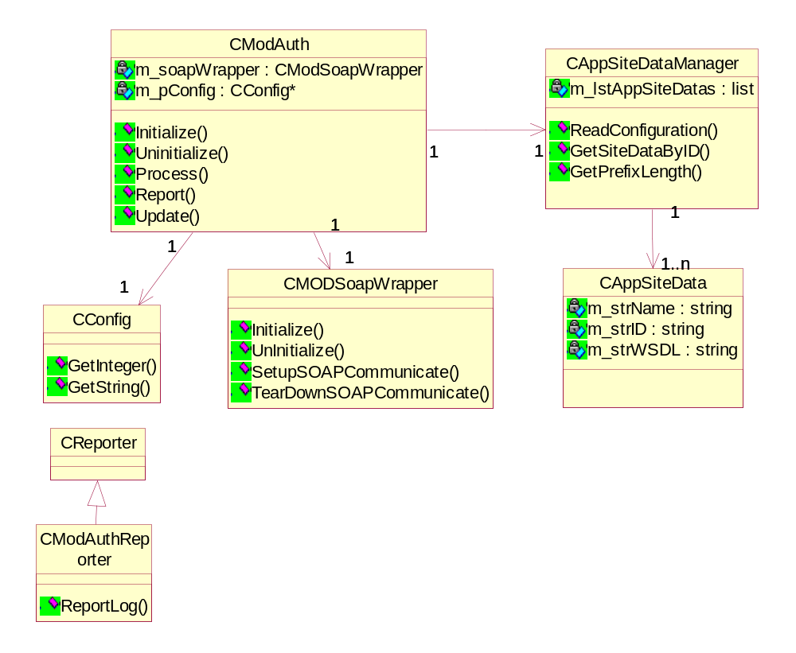

Workflow
The product requirements ask for no credit checking when the request is just for previewing an Asset. In order to realize this requirement, the RTSP (DSMCC) should set the BillingID and PurchaseID to be zero. When MOD plug-in get Billing ID equal to zero, the Process routine will return TRUE right now and there is no SOAP communication between MOD plug-in and OTE.

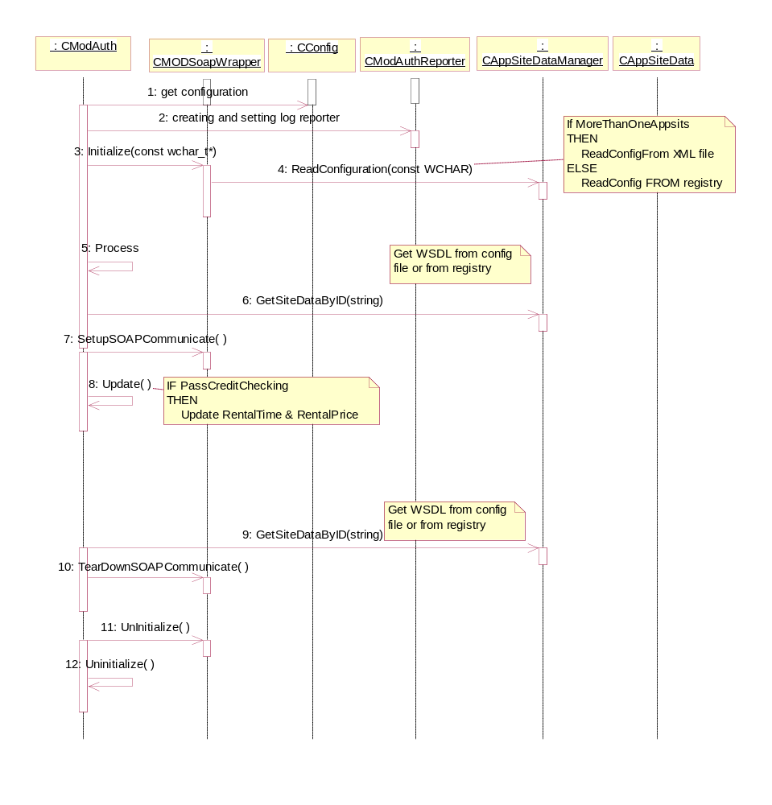

Registry and configuration setting
There are two parts register setting for MODAuthorization DLL. One is the setting used by MOD, which tell MOD which plug-in will be loaded. Another is used by MODAuthorization DLL itself.
1. Register items for MOD:
\\HKEY_LOCAL_MACHINE\\SOFTWARE\\seachange
\\ITV Application\\CurrentVersion\\services\\Movies On Demand
AuthorizationDllName = MODAuthorization.dll
AuthorizationDllPath = c:\itv\exe
AuthorizationDllTimeOut = 0x10000

2. Register items for MODAuthorization DLL
\\HKEY_LOCAL_MACHINE\\SOFTWARE\\seachange
\\ITV Application\\CurrentVersion\\services\\Movies On Demand\\AuthorizationDLL
LogFilePath=
LogFileSize=
LogFileTraceLevel=
SOAPWsdlPath=
AppSitesConfigurationFile=

3. If there is AppSitesConfigurationFile in registry and it is not empty string, MODAuthorization will load the application site information from configuration file, otherwise, the default application site is identified by SOAPWsdlPath.

4. The AppSitesConfigurationFile’s xml format is:
<ApplicationSites PrefixLength="2">
<AppSite
Name="AppSite1"
ID="01"
WSDL="http://ZAP_WFES1:9090/services/MoDSoapInterface?wsdl" />
<AppSite
Name="AppSite2"
ID="22"
WSDL="http://ZAP_WFES2:9090/services/MoDSoapInterface?wsdl" />
</ApplicationSites>

Error Handling
  - If Online Transaction Engine failed down, MOD Service Plug-in will return FALSE ignores any situation. Then MOD will reject the stream request.
  - If timeout occurred in the communication between MOD Plug-in and Online Transaction Engine, MOD Plug-in will return FALSE to MOD immediately. Then MOD will reject the stream request.
  - If any unexpected error occurred in the communication phrase between MOD Plug-in and Online Transaction Engine, MOD Plug-in will return FALSE. Then MOD will reject the stream request.

